WBC2024 Update: Call for Symposia is Now Open!
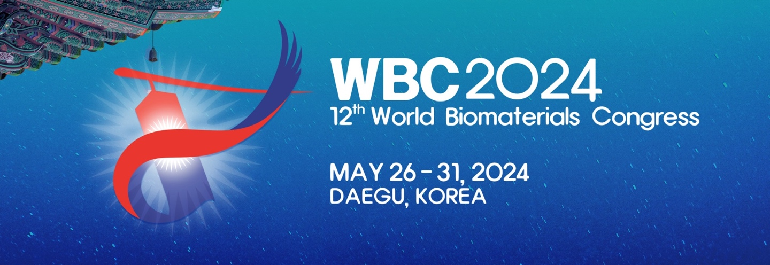

The call for symposia is now open!
The Scientific Program Committee of WBC2024 are soliciting proposals for symposia at the upcoming World Congress in Daegu, Republic of Korea (May 26 – May 31, 2023). To learn more, please visit the WBC2024 Call for Symposia webpage.
Submission Deadline: January 15, 2023
Notification of Acceptance: March 1, 2023
Online Submission Form
If you are planning to submit a Symposia Proposal, please let us know at support@biomaterials.ca so we can help support your efforts!

Other WBC2024 dates to remember:
Abstract Submission: April 1, 2023 – September 31, 2023
Early-bird Registration: April 1, 2023 – February 29, 2024

